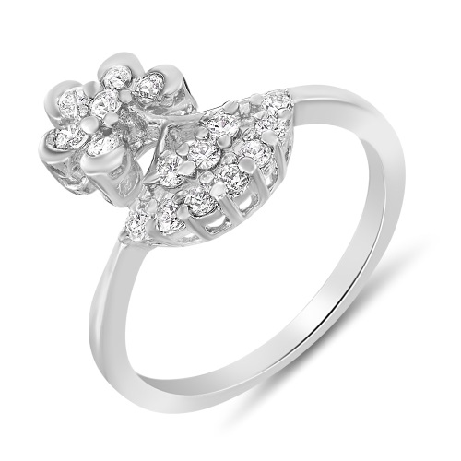

Beautiful, brilliant and now extraordinary! Standing in admiration this breathtaking piece pours a pleasing spirit within the wearer. Manufacturer: Mahi Fashion Jewellery Warranty: 6 Months Manufacturer Warranty .

Product: MAHI

Price:3,120.00 PKR

CONTACT US: Address: Aptech Metro StarGate Karachi

Phone.no: 03142191402

Email: feedback@aptech-educationcom.pk